**Project: Analyze NYSE Data**

**In year 4, what is the revenue of IT companies?**

The average revenue of IT companies in year 4 is 12,864,993,096 whereas the median for the year is 4,000,945,500. The mean is almost three times that of the median. Hence, the data is skewed to the right.

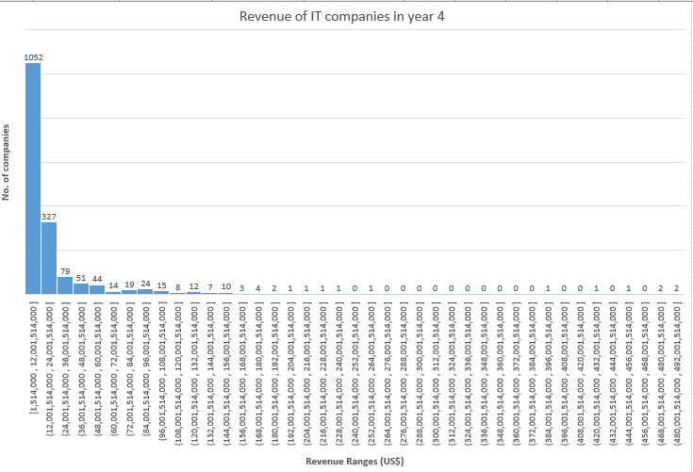

Based on the following histogram, we can conclude that the revenue of the IT companies in year 4, is positively skewed.

Also, the mode (i.e. most frequent revenue for 49 companies) is between US$ 1-32 billion. The standard deviation 30,933,009,016 shows that the vales are more spread out. Also, the high skewness can be explained with the presence of just 1 company between the range of US$ 211-241 billion, which in some studies can also be considered as an outlier as rest of the companies lie in the range of US$ 1-90 billion.

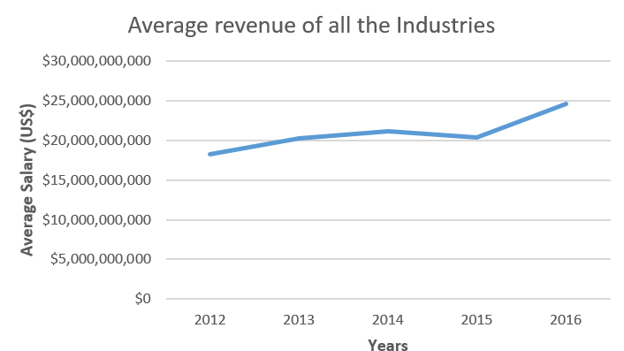 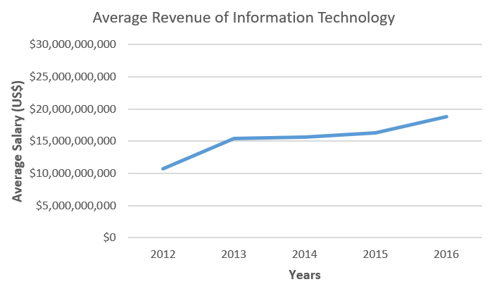

Based on the above two line-charts, we can understand that how the revenue of Information Technology has almost double from 2012 to 2016. However, the overall revenue has not seen such huge growth over the same time duration.